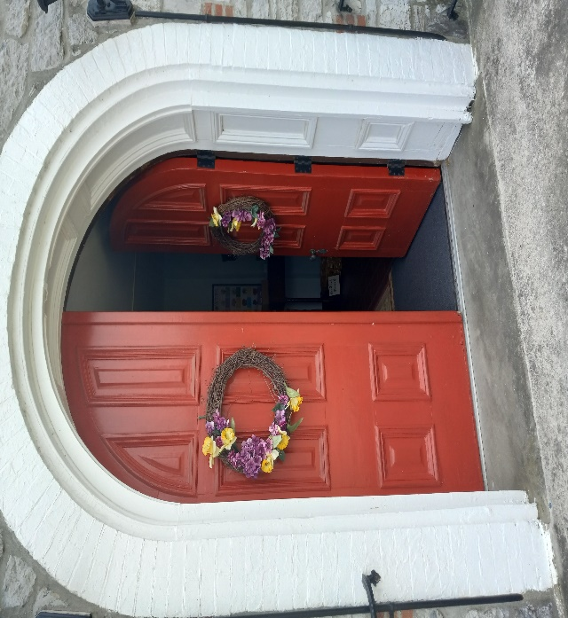
Presbyterian Church of the Upper West Conococheague
The Settler
Church Office
34 W.Seminary St.
Mercersburg, PA 17236
Phone: 717-328-2510
Email:thesettler1738@gmail.com
Webpage: mercersburgpcuwc.com Issue LII volume 10 October 2025

Are You a Fan or Atic?
By George E. Davis
While driving back from the library this morning, I saw, outside the barbershop I patronize, a small white convertible screaming with bumper stickers, paintings and pictures of the New England football team. There was less than four inches anywhere on that vehicle there wasn't some mention of that team boldly emblazoned on it's white surface.
Seeing that vehicle made me wonder, what do people think when they see that person coming down the street, his car covered in football decals and murals. He is a football fan, a man who loves his team. Now take that same car, put one bumper sticker on the rear bumper, one of those you have to get real close to read, 'I Love Jesus'. What would they say about that driver now? He's a religious fanatic, one of those Jesus Freaks most likely.
How many times have you watched a football game on television and when the camera pans the audience you see shirtless men with one half of their bodies, including faces, painted one color and the other half painted another color. Hold on, those men are just fans. They are rooting for their team to win, waving their big sponge number one finger in the air, hooting and hollering until they leave the stadium hoarse and nearly speechless. Now go to church Sunday morning and the deacon in the rear of the church says Amen when the pastor makes a point in his message that is honoring the creator of this universe, and what does that football fan think? That deacon is a religious fanatic, a real nutcase. Don't you remember, only yesterday you painted your body two colors, including your face, you screamed and hollered until only a squeak emanated from your vocal chords, but the deacon is a religious fanatic?
The word Fan is short for Fanatic, but the inference is quite different as you can see. According to society it is all right to be a fan, but not a fanatic. It is okay to hold up a sports figure as a role model, one who has admittedly cheated on his spouse, has taken steroids to enhance his game, and even smoked dope, but anyone who says Jesus is his or her role model, they are labeled a religious fanatic, a screwball, a nut.
When you appear before the Judgment Seat of Christ it isn't going to be how much you know about any sports game or hero, but do you know Him, the one who died for you? There isn't a sports figure in the history of any sport who can save you.
Next time you go to church try getting excited for Jesus. Say amen, let the pastor know you enjoy his message, and above all worship, worship, worship and praise, praise, praise the Lord Jesus Christ who gave His life for you. Remember Him, make the Lord your role model.
You wouldn't be embarrassed if someone called you a sports fanatic, so neither should you be ashamed if someone calls you a religious fanatic. Fall in love with Jesus your redeemer, trust Him, not a sports figure, for your salvation. Cheer for Jesus. Get excited for the Lord, it is all right to shout Amen once in a while, or when you want to.
If you were at someone's house and they were cheering for a different team than your team, you would probably argue the finer points of your players and their prowess, you would stand up for your team against all odds. Now if, you were at that same person's house and he or she was discussing religion and they were members of a cult. Would you stand up for Jesus if they were to berate Him, or make heretical statements about His deity? Or would you let them use the creator of this universe for a door mat? The choice is yours.
Stand up, stand up for Jesus! Ye soldiers of the cross; Lift high His royal banner, it must not suffer loss, Stand up, stand up for Jesus! Ye soldiers of the cross; Lift high His royal banner, it must not suffer loss: From vict'ry unto vict'ry, His army shall He lead, Till every foe is vanquished, and Christ is Lord indeed. That old hymn says it all.
"For I am not ashamed of the gospel of Christ: for it is the power of God unto salvation to every one that believeth; to the Jew first, and also to the Greek." (Romans 1:16) If you can, with Paul, say that, then you must be a fan of the Lord Jesus Christ. Do not let people intimidate you, let them know that it is rather better to know Jesus and praise His name, than to spend your 'weekends' praising some sports hero who you wouldn't trust with your own daughter.
God Bless your day my friends...Remember Jesus is still Lord!

To be born is a gift. To live is a grace. To choose life even in dark days is a posture of faith. To celebrate in the sunshine of good times is a blessing.
We wish all on our list a happy birthday and a thousand days of sunshine.
October Birthdays
3rd Bridget DeLany
11th Shelley Main
14th Ann Wagner
13th Tom Ralston
16th Erika McDowell
19th Tiffany Jones
23rd Dian Bishop
26th Ella Lee Ann Jones
29th Koltin Bricker

October Anniversaries
4th Tyler & Eliza Robinson
26th John & Denise McDowell

Humor:
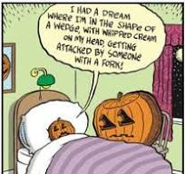

”The Lord your God who goes before you, will Himself fight on your behalf” Deuteronomy 1:30
We Remember in Prayer
Those in the Military/Armed Forces:
- Lt Col Josh King
- Lt Col Benjamin Beidel
- Cmdr Steve Velthuis, Sr.
- Steve Velthuis Jr.
Members and Friends in need of Prayer:
Jack Calkins – and wife Ann
Joanna Starke – Dee Atkisson’s daughter
Louise and Tom McDowell
Little AJ – Dee’s grandson
Ann Wagner
Kathy – Marty’s Sister
Regina Taylor
Nancy Robinson
Our cancer fighters:
Dean Dovey
Judy Brightbill
Joe Angle
Tim Svehla
Martha Hetzer
Jan Mayeski
And all others on our hearts and minds.
“When you pray, you are inviting God to become involved in your circumstances and actively placing the results into His Sovereign, capable, willing hands.”
From: Charles Stanley devotional
Mission Fellowship:
Mission Fellowship meets on the first Wednesday of each month and is a time of fellowship, sharing our faith and planning our ministry to the community. All are welcome to not only join us but to give input into the plans we make.
Operation Christmas Child shoeboxes in October. We’ve received a very large donation of Ty bears for the shoeboxes. Our goal is 75 boxes. Items to put in box will be available first Sunday in October, we are asking for monetary donations to help with shipping costs. ($10 per box this year)

Church Growth Committee:
Save the Date! October 11th from 5 to7pm we will be having a folk music festival, we have several local musicians lined up to entertain and will be serving hotdogs and other things to fill you up.
We are also working on serving a once a month international dinner in 2026. We’ll need everyone’s best recipes from all over the world.
From Your Session:
We are close to getting the aisle carpeting in the sanctuary replaced. We are looking into ways to save money on some of our annual expenditures.
The Church Hill Cemetery has been cleanup of brush, downed limbs and a bad tree. Next need at cemetery is the stone wall needs repaired in several places.
We are also getting bids on upgrading our sound system.
Do You Pray?
I loved this interpretation of prayer.
What is a prayer?
Prayer doesn’t just happen when we kneel or put our hands together and focus and expect things from God.
Thinking positive and wishing good for others is a prayer.
When you hug a friend, that’s a prayer.
When you cook something to nourish family and friends, that’s a prayer.
When we send off our near and dear ones and say, “Drive safely” or “be safe”, that’s a prayer.
When you are helping someone in need by giving your time and energy, you are praying.
When you forgive someone in your heart, that is prayer.
Prayer is a vibration. A feeling. A thought.
Prayer is the voice of love, friendship, genuine relationships.
Prayer is an expression of your silent being.
Keep Praying Always!
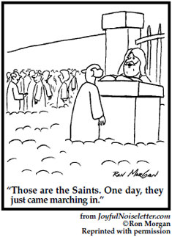
October Calendar
1 – 5pm – Mission Fellowship meets in Chapel and on zoom.

5– Sunday – Morning Worship at 10:30am in sanctuary and on Zoom, with Revs. Moore
World Communion Sunday =The Lord’s Supper will be observed.

6 – Monday – 1pm – Bible Study resumes at Fendrick Library= Studying the Book of Acts
with Aaron Mayeski.

7 -Tuesday – 11am – Mercersburg Area Churches will meet in our chapel and on zoom.

7- Tuesday – 5-7pm – Bountiful Blessings distribution at the Mennonite Church

9 – Thursday -1:30pm – Book Club meeting, this month Before We Were Yours by Lisa
Wingate

11 – Saturday = 5 to 7pm – Music Festival! Local artists, held on Park Street lawn of Church, serving hotdogs, popcorn, drinks and cookies. Bring lawn chairs and enjoy a night of music and fellowship. (In case of inclement weather, we will move into the chapel).

12- Sunday - Morning Worship at 10:30am in sanctuary & Zoom, with Revs. Moore

13 – Monday – 1pm – Bible Study at Fendrick Library= Studying the Book of Acts
with Aaron Mayeski

13– Monday – 5:00pm – Session meets in chapel and on zoom.

14 – Tuesday- 5-7pm – Bingo at Brindle Terrace, Happy Columbus Day.

19 – Sunday - Morning Worship at 10:30am in sanctuary & Zoom with Revs. Moore

20 – Monday – 1pm – Bible Study at Fendrick Library= Studying the Book of Acts
with Aaron Mayeski

21 – Tuesday: 5-7pm – Bountiful Blessings distribution at the Mennonite Church

26 – Reformation Sunday –Morning Worship at 10:30am in sanctuary & Zoom, with Revs.
Moore. Celebrating the beginning of the reformed tradition.

26 – 4pm – Formal installation of Revs. Moore to our congregation. Heritage Presbytery and other churches will be in attendance, refreshments provided after the service.

27 – Monday – 1pm – Bible Study at Fendrick Library= Studying the Book of Acts
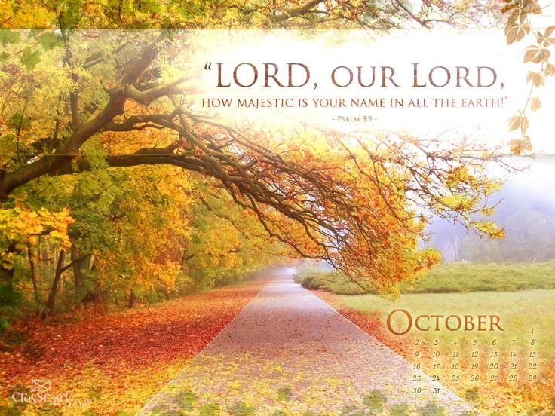

The Presbyterian Church of the
Upper West Conococheague
34 W. Seminary St. Mercersburg, PA

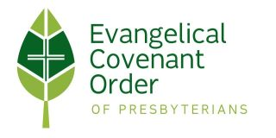

Sharing God’s Love
in our community

